Relational Behaviour Policy

Created: January 2025
Review Date: January 2026

Signed: Tash Hughes – Head of School
Signed: Sue Lau – Proprietor

Contents:
- Introduction
- Myles Academy Approach to Behaviour Management
- Trauma Informed and Attachment Aware School (TIAAS)
- Emotion Coaching
- Strategies for helping children to achieve these expectations.
- Positive Attitudes to Learning
- School Rewards and Sanctions
- Use of reasonable force
- Responsibilities
- Mobile phones and other electronic devices
- Visits and Journeys
- Anti-Bullying
- Staff Training
- Seeking the views of children, parents, carers, local authorities and staff
- Risk assessments and Behaviour Management Plans (RA / BMP)
- Safeguarding and child protection
- Behaviour outside of Myles Academy’s premises
- Powers to search
- Complaints
- Reporting and recording incidents and sanctions
- Implementation, monitoring, evaluation and review
Appendix 1: Myles Academy Expectations
Appendix 2: Risk Assessment / Behaviour Management Plan
Appendix 3: RPI/Incident form

- Introduction
At Myles Academy we work to encourage each individual to reach their full potential in a caring and relaxed but purposeful, disciplined atmosphere. Myles Academy strives to create a school community which is trauma informed. This trauma informed approach is embodied by our aspiration to build a nurturing and caring ethos which permeates our school environment. We have developed a behaviour policy which places relationships as the cornerstone for children/young people to thrive, both academically and in relation to their wellbeing. Our school aims to;
- Provide a positive and caring environment where every member of the school community is valued; achievements are recognised and successes celebrated.
- Provide a broad balanced, differentiated curriculum enabling each student to further develop his or her abilities.
- To actively promote good behaviour, self-awareness and self-control in a climate of mutual respect.
- Promote good habits, attitudes to work and where appropriate with student involvement, in planning and recording.
- Work as a community where understanding, respect for others and personal responsibilities are central values, allowing everyone to flourish as individuals.
- To ensure staff and students recognise and understand their rights and responsibilities, and work with us to secure good behaviour and develop their social skills.
- To ensure that staff have a consistent approach in promoting positive behaviour.
- Follow the DfE guidance on Exclusion from maintained schools, Academies and pupil referral units in England, Reference: DFE-57501-2012
Myles Academy recognises its duty under the Education and Inspections Act 2006 to establish and maintain a behaviour policy for the school that promotes self-discipline, respect for others and proper regard for authority; and to make arrangements to ensure that functions are carried out with a view to safeguarding and promoting the welfare of children in accordance with the Education Act 2002. We also comply with The Education (Independent School Standards) Regulations 2014 and have regard to the DfE guidance ‘Behaviour and discipline in schools’ (2016). Myles Academy acknowledges the obligations associated with the Children Act 1989, the Human Rights Act 1998 and the Equality Act 2010. We also follow current DfE guidance ‘Keeping children safe in education’ (2024), ‘Working together to safeguard children’ (2018)1, HM Government advice ‘What to do if you’re worried a child is being abused’ (2015) and the Local Safeguarding Children Partnership’s policies, procedures, guidance and protocols.
- Myles Academy Approach to Behaviour Management
We have developed our whole school policy to promote positive behaviour in line with DfE guidance ‘Behaviour and Discipline in Schools’ (2016) and the 4R’s framework. This also works in partnership with TIAAS. Systems and processes are built around the key aspects outlined in DfE guidance.
- A consistent approach to behaviour management
- Strong school leadership
- Positive reward system
- Classroom management
- Teaching of good behaviour
- Staff development and support
- Pupil support systems
- Liaison with parents and other agencies
- Managing pupil transition
- Organisation and facilities
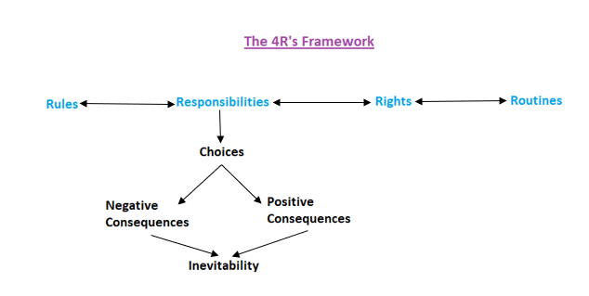
An important first principle is that supporting good behaviour is the responsibility of all members of staff. During any teaching session, the prime responsibility is that of the class teacher, with support available from TAs, key workers and senior managers where such intervention is felt necessary. This responsibility remains with the class teacher (whether or not the decision has been taken to remove a pupil from class) and a welcoming environment/approach as well as appropriately differentiated work must be available for every teaching session.

Some of Myles Academy’s rights and responsibilities include:
- To work well in class, without disturbing others.
- To treat other people with respect, politeness, tolerance and consideration.
- To take care of other people’s property, including Myles Academy property.
- To co-operate with reasonable requests, instructions, corrections and sanctions from staff.
- We have a responsibility to deal with any difficulties or disagreements, in a calm, reasonable and honest manner.
- To be responsible for managing our own feelings and behaviour, as well as possible.
- To be responsible for preparing children for adult life, higher education, the work environment and independent living.
- We have a responsibility to look after each other and not to accept bullying or discrimination.
- We have the right to a positive learning environment.
- We have the right to the best teaching and curriculum.
We underpin rights and responsibilities with clear rules and routines to ensure that the school day runs smoothly, and everyone is clear how they can contribute. The Myles Academy Expectations outlines the expectations which are revisited and reviewed in partnership with students each half term (Appendix 1). Rules and routines are explained during induction then rehearsed and implemented each day making expectations really clear.
Having established specific routines and expectations of behaviour at an early stage, these are then regularly reinforced and maintained through the following:
- Time spent daily with key workers
- Assemblies
- Personal Social Health and Citizen Education
- During lesson time
- Mentoring sessions
- Written signs clearly stating expectations of Myles Academy
- Good role models presented by staff and other students
- Break and lunch time supervision
- 1-1 sessions
Through these opportunities staff at school actively teach what is meant by good behaviour, as well as regularly reminding pupils of the Myles Academy Expectations, so that students clearly understand what is expected of them at all times and in all areas within school.
Myles Academy embed the PACE (Play, Acceptance, Curiosity, Empathy) approach originated by Hughes in order to support a child’s social engagement system. The development of positive pupil/staff relationships along with effective teaching which recognises individual needs encourages children to behave in appropriate and less challenging ways.
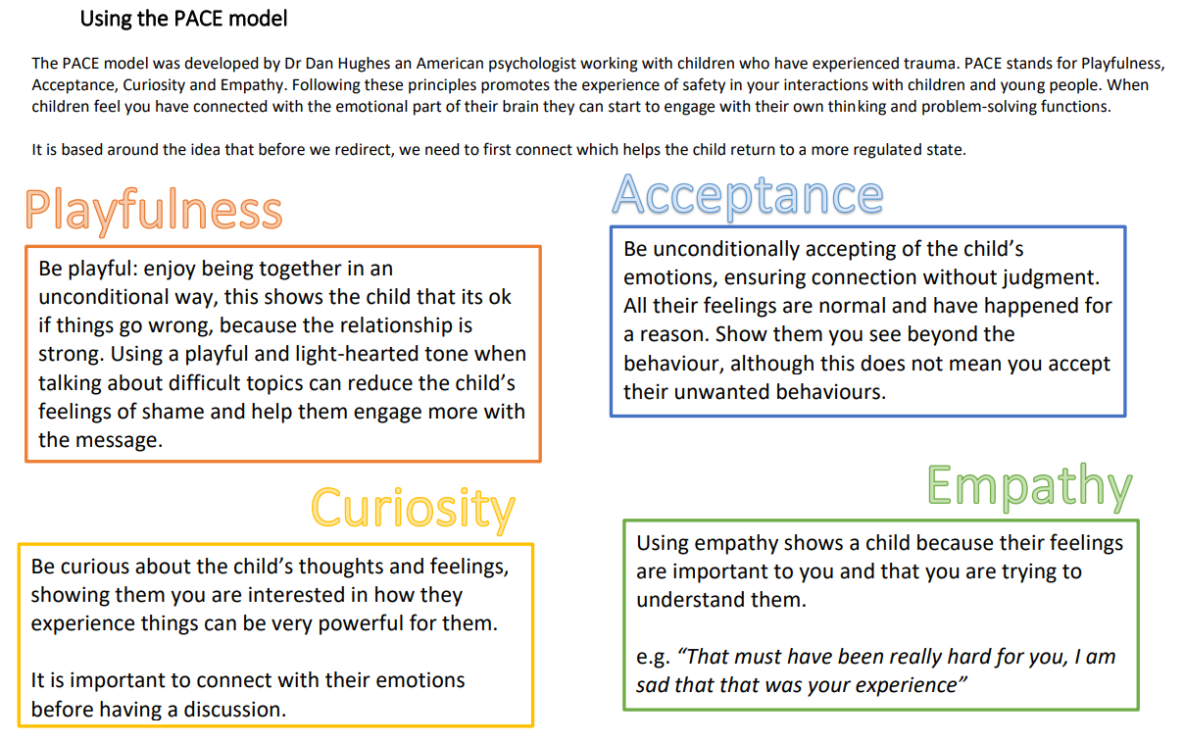
Staff use a range of strategies which allow pupils to learn how to manage their emotions more effectively without disrupting the learning of others. These strategies may include:
- Time alone in another part of the classroom
- Time out of class with a known adult supporting
- Behaviour Mentor or teaching Assistant intervention
- Use of a calm/sensory box
- Use of time away
- Use of a quiet room
In order to model appropriate behaviour in at break times, teaching and support staff play games and encourage the children to play appropriately with their peers. Staff will supervise children during lunch and breaks at all times and a rota for this is in place. This establishes strong relationships between pupils and staff, providing secure attachments and key adult figures.

- Trauma Informed and Attachment Aware School (TIASS)
Myles Academy strives to have a whole school approach to mental health and wellbeing for our pupils and staff. This involves staff applying Trauma Informed, Attachment Aware and Emotion Coaching Approaches in their everyday practice, with a particular focus on the central principles of empathy, connection, attunement, trust and co-regulation.
Myles Academy, in partnership with Birmingham Educational Psychology Service, have taken part in a whole school development programme to ensure this approach is embedded in school life.
By applying Trauma & Attachment and Emotion Coaching principles at Myles Academy, we can foster an inclusive approach to meeting the needs of all young people within our settings, including:
- A reduction in exclusions for vulnerable pupils with both identified and unidentified SEMH.
- Better outcomes around staff emotional mental health and well-being (EMHWB), such as sickness absence and retention, (due to the emphasis that such approaches place on the EMHWB of the whole school community).
- Empowering staff to respond to presenting behaviours in a way that is empathetic but still acknowledges the need to set limits and boundaries on certain behaviours.
- Encouraging all Myles Academy staff to ‘connect before you correct’. This is achieved by empowering staff to look beyond the often very challenging behaviours displayed by young people and question what emotions might be driving these behaviours. Only when young people feel a sense of being heard, understood and cared about, can they begin to express their emotions in a more acceptable way.
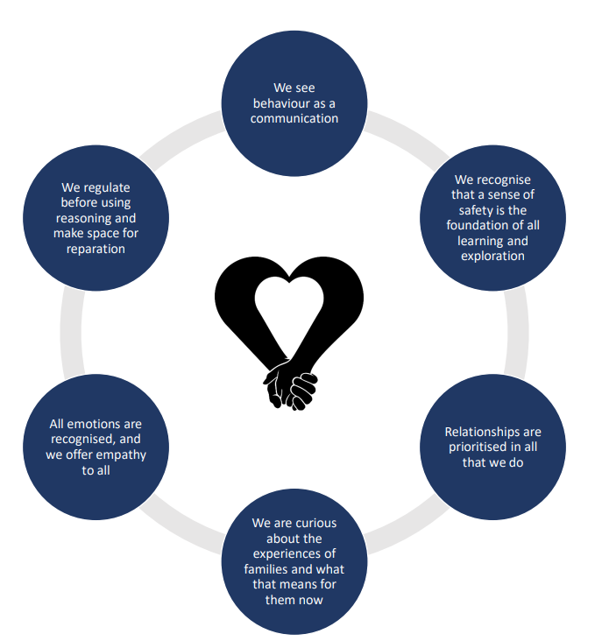
TIASS principles

- Emotion Coaching
Emotion Coaching focuses on the development of emotional regulation through supportive relationships. It can benefit not only young people, but also parents/carers and professionals, to better understand and regulate their emotions, in order to manage strong feelings and take ownership of behaviour.
- Emotion Coaching offers practical steps for responding to behaviour, and is linked to key attachment concepts, such as the importance of connection.
- Emotion Coaching is an evidence-based approach that provides an understanding of the neuroscience behind behaviour.
- Research indicates that staff in schools feel more confident managing behaviour when they have increased knowledge of the link between behaviour and emotion.
The following principles are central to Emotion Coaching:
- All emotions are natural and normal, and not always a matter of choice.
- Behaviour is a communication.
- Emotional ‘first aid’ (calming, soothing) is needed first: ‘Connect before re-direct’ (Siegel, and Bryson 2011), ‘Rapport before reason’ (Riley, 2009)
- ‘Emotion coaching builds a power base that is an emotional bond – this creates a safe haven, a place of trust, a place of respect, a place of acceptance, a sense of self. This in turn leads to children and young people giving back respect and acceptance of boundaries’ (Rose and Gilbert, 2017)
- Children cannot successfully self-regulate their emotions unless they have experienced and internalised co-regulation (i.e. an adult tuning in/empathising with their emotional state and thus ‘containing’ - sharing, supporting and carrying – their emotional state). This also involves explicit teaching and modelling.
There are four different stages of Emotion Coaching:
1. Recognising, empathising, soothing to calm (‘I understand how you feel, you’re not alone)
2. Validating the feelings and labelling (‘This is what is happening, this is what you’re feeling’)
3. Setting limits on behaviour (we can’t always get what we want’)
4. Problem solving with the young person (‘We can sort this out’)
Steps 1 & 2 of the Emotion Coaching Framework outlined above provide an opportunity to prioritise relationships, empathise, and support the child or young person to feel safe. Step 3 & 4 of the Emotion Coaching Framework provides opportunities for behaviour reflection, behaviour change, discussion around consequences and opportunities for problem solving.

- Strategies for helping children to achieve these expectations
- Consistently emphasising the importance of the above behaviour, in word and through example, during both formal and informal times of day
- TIAAS approach from staff at all times
- Emotion Coaching
- Building, protecting and preserving secure, positive relationships between staff and children
- Treating each child with understanding, dignity, kindness and respect
- Understanding each child’s behaviour, to allow their needs, aspirations, experiences and strengths to be recognised and their quality of life to be enhanced
- Supporting each child to balance safety from injury (harm) with making appropriate choices
- The provision of a well-trained, confident, calm, assertive staff team, who are aware of what standards of behaviour to expect; what action to take to promote it; and are consistent in their approach
- Setting high expectations for attendance, appearance, punctuality, achievement and behaviour for all children and staff
- Setting clear, consistent, appropriate rules and boundaries for behaviour that children understand, so that they are clear about what is expected of them in all situations
- Placing an emphasis on changing behaviour through recognising and rewarding good behaviour, rather than focusing on bad behaviour
- Planned rewards and encouragements for both work and behaviour, so that all children know that their efforts and achievements are recognised and appreciated
- Fair warnings and predictable consequences for adverse behaviour, using the minimum levels of sanction likely to be effective
- Using effective de-escalation techniques and creative alternative strategies, that are specific to the individual needs of each child and designed in consultation with them, where possible
- Helping children to develop the skills and strategies necessary, to understand and manage their own behaviour, conflicts and feelings safely, through discussion and reflection
- Teaching a broad and balanced curriculum, which promotes the spiritual, moral, cultural, mental and physical development of children; while placing a strong emphasis on the fundamental British values of democracy: the rule of law, individual liberty and mutual respect and tolerance of those with different faiths and beliefs
- Including children in planning their programmes, discussing the best ways to make progress and reviewing that progress
- Providing educational opportunities, comparable to those in mainstream education, to promote a sense of real achievement
- Using the best principles of teaching and classroom management, to minimise distractions and to optimise academic and vocational achievement
- Providing enjoyable experiences with other children, that leads to and develops friendships
- Ensuring a safe community where no child is unduly pressured by either adults or other children, and no unnecessary restrictions are imposed
- Recognising and praising improvements, however small, and sharing that information with significant people
- Involving children, parents, carers and relevant others in behaviour management, support and decision making.
- Positive behaviour and relationships are encouraged, reinforced, praised and celebrated. Poor behaviour is challenged and discussed.

- Positive Attitudes to Learning

Having confidence and a positive attitude to learning is crucial to a pupil's success in school. We are relentless in our pursuit of positive attitudes to learning and we assess all pupils through our Personalised Pastoral Program. Myles Academy aims for all pupils to have the following:
- Are motivated and have positive attitudes towards their learning.
- Are committed to their learning.
- Know how to study effectively and do so.
- Are resilient to set backs.
- Take pride in their achievement.
The personalised Pastoral Program will see pupils work with staff on an initial 1-1 basis and try to highlight areas of strength’s and concern. This will take into account the pupils, and other relevant staffs views. Pupils will then work on an individualised program designed to help support, nurture and give pupils the tools and skills they need.

- School Rewards and Sanctions
At Myles Academy we aim to reward those students who manage themselves within the rules and expectations. These are some of the positive things on offer:
- Daily money rewards for getting stars through the S.T.A.R. reward system.
- Verbal Praise
- Prizes through the point reward system.
- Celebration of achievements and success with presentations, prizes and certificates.
- Phone calls home
- Letters or praise postcards
- Personalised responsibilities/privileges
- Recognition of events in the school’s newsletter
- Lunch time clubs and activities
- Special visits and day trips
- Congratulatory letter to parents

STAR Reward System
We try to reward and incentivise good behaviour on a daily basis through a point (S.T.A.R.) reward system. We set parameters for good behaviours in and out of the school environment, completion of set work and tasks and outstanding achievement. When parameters are met and/or exceeded, stars are awarded which translate to money. Each pupil has their points recorded each lesson on their individualised star chart. These are then reviewed at the end of the day with a discussion about achievements or why they didn’t meet expectations.

Sanctions
Sometimes students are unable to manage themselves within the boundaries of the ‘School Expectations.’ When this happens, we will endeavour to explore with the student or students involved the particular behaviour deemed unacceptable and to explain why it is inappropriate. Appropriate actions are then taken, to achieve the following:
- The removal of a student from a negative situation
- Supporting the student by giving them the time and space to calm down and discuss the area of conflict
- Ensuring that other students are not disrupted
- Maintaining a calm, orderly atmosphere in school
- The understanding on the part of the student that poor behaviour and missed class work will have a consequence.
Sanctions are a consequence as a result of behaviour and are intended to change behaviours. When negative behaviour occurs staff will adopt the following steps;
- Reminders and prompting towards rights and responsibilities
- Use the language of choice to encourage positive choices
- 3 Warning system
- Loss of points
- Quiet area
- Emotion Coaching
The ultimate aim when modifying behaviour is returning the child to learning, so when sanctions are issued it is done clearly and swiftly so we can move on and get back to positive learning.
The sanctions we may use include:
- Loss of points
- Restorative tasks (e.g., clean up or helping out)
- Restorative work
- Reflection time/time out to think and reflect on positives and solutions
- Mediation/restorative meeting to resolve difficulty with peer or staff member
- Time with a member of SLT
- Phone calls home
- Letters home
- Meeting with parents or guardians
- Fixed term exclusion (which may only be sanctioned by the Headteacher or Acting Headteacher)
- Permanent exclusion (following consultation and involvement of the proprietor and the Local Authority)
Police Involvement
Myles Academy aims to have an excellent relationship with our local Community Police Officers. Regular visits will be made into school and in extremis, their services will be requested for particularly difficult circumstances. The aim is that this support will have a very positive impact on school and will serve to improve the relationship between the police service and our pupils. There may be incidents where involvement of the police is felt necessary. In all cases, contact with the police must be channelled through the Headteacher (or Acting Headteacher). It is expected that staff will consider the balance between meeting the needs of what are essentially a group of socially and emotionally damaged young people and the rights of staff as individuals. The school makes every effort to avoid criminalising these young people. Careful, child-centred decision-making is made about reporting their behaviour to the police, though appropriate notifications are always made and clearly documented. If the behaviour could be criminal or poses a serious threat to a member of the public, the police should always be informed. NPCC When to call the police: Guidance for schools and colleges should help senior staff understand when they should consider calling the police and what to expect when they do. A decision whether or not to involve the police will be made by the Head Teacher.

- Use of reasonable force
At Myles Academy, we ultimately want a ‘Hands Off’ approach and do not aim to use physical intervention as a strategy.
We do recognise that there may be times when we would need to use reasonable force to:
- Remove disruptive children from the classroom where they have refused to follow an instruction to do so
- Prevent a pupil behaving in a way that disrupts a school event or a school trip or visit
- Prevent a pupil leaving the classroom where allowing the pupil to leave would risk their safety or lead to behaviour that disrupts the behaviour of others
- Prevent a pupil from attacking a member of staff or another pupil, or to stop a fight in the playground
- Restrain a pupil at risk of harming themselves through physical outbursts. (Taken from DfE Use of Reasonable Force, 2013)
In any instance where force is used it will be documented on an RPI/Incident for and parents/carers and any other relevant professionals will be informed.

All sanctions must be reasonable, proportionate and time-bound. Sanctions must not include:
- Any form of corporal punishment, including the unnecessary use of force
- Any punishment involving the consumption or deprivation of food or drink
- Any restriction on a child’s contact or communication with parents, relatives, advocates or friends
- Any restriction on a child’s access to any internet-based or telephone helpline providing counselling for children
- The use or withholding of medication, or medical or dental treatment
- Imposing a financial penalty, other than a requirement for the payment of a reasonable sum by way of reparation
- An intimate physical examination
- Withholding any aids or equipment, needed by a disabled child
- Humiliation (including any requirement that a child wear distinctive or inappropriate clothes)
- Isolation
- Any measure which involves: a) any child in the imposition of any sanction against any other child; or b) the punishment of a group of children for the behaviour of an individual child similarly, we must not threaten a child with the above sanctions or make them think that they are possible.

- Responsibilities
The Head Teacher and SLT’s responsibilities include:
- To ensure that the behaviour policy reflects the aims of the school
- Taking the role of lead behaviour professional to develop and uphold systems, support staff and secure good progress for students.
- To ensure that all relevant parties including staff, proprietors, parents and students are fully aware of, and as far as possible committed to the school’s behaviour policy
- To ensure that the behaviour policy is consistently and fairly applied throughout the school
- Liaison with parents and outside agencies
Class Teacher’s Responsibilities Include:
- To make students aware of the expectations and rules of Myles Academy
- To ensure Myles Academy expectations and rules are embedded into each and every teaching session
- To use the opportunities available to actively teach and promote good behaviour
- To use the systems for rewards and sanctions as consistently and fairly as possible
- To liaise with other staff, parents and outside agencies where appropriate regarding individual students
- To present as a good/positive role model, particularly in terms of dress code, punctuality and a positive approach.
Classroom Support Assistant’s/Inclusion Team/Key Workers Responsibilities Include:
- To be aware of and implement the school behaviour policy
- To support the class teacher in implementing the behaviour policy
- To use the systems for rewards and sanctions as consistently and fairly as possible
- To present as a good/positive role model, particularly in terms of dress code and punctuality.
Student’s responsibilities include:
- To understand the importance of the Myles Academy Expectations and its benefit for their own learning
- To try to meet the school’s expectations and follow the school rules
- To aim to achieve progression through the point reward system
- To aim to achieve personal targets (for example those set in EHCPs, IEPs or by class teachers) and be actively participant in the development of such targets.
Parents, Guardians and Other Carers responsibilities include:
- To support the school in implementing the behaviour policy and promoting good behaviour
- To advise the school of any concerns about their child’s behaviour in school and support the school’s efforts to resolve any difficulties.

- Mobile phones and other electronic devices
It is acknowledged that mobile phones and other electronic devices will be brought into school by some pupils for a variety of reasons e.g. independent travellers. The use of such devices on school premises is not permitted unless under the express permissions of a member of staff.
All pupils are expected to hand in their mobile phones at the start of the school day. These will then be kept in a secure location and each individual pupil will have their own “Phone bag”.
Pupils found using such a device in contravention this policy will be instructed to stop using the device. They should be allowed to hand it in to a member of staff. Where there is further inappropriate use of the device the pupil will start the 3warning process. Devices will be returned to the pupils at the end of the school day. If there is repeated inappropriate use of such devices by the same pupil then consideration should be given to contacting their parent/carer with a view to banning the pupil from bringing such devices into school for an appropriate length of time.
- Visits and Journeys
High standards of behaviour are expected on all school trips and visits including daily travelling to and from school. All Myles Academy Expectations and Rules are consistently applied throughout visits and journeys.
- Anti-Bullying
Any bullying including racial harassment is serious and unacceptable. The school’s Antibullying Policy aims to prevent bullying by using a range of strategies. Incidents of bullying will be treated seriously and dealt with as stated in the Anti-Bullying Policy which should be read in conjunction with this policy.
- Staff training
We are committed to training all relevant staff in effective behaviour management including the principles and purpose of our policy, our legal responsibilities, how to recognise and de-escalate behaviour of concern and where to seek support
- Seeking the views of children, parents, carers, local authorities and staff
Regular enquires are made of all children as to how safe they feel at Myles Academy and ways in which services and outcomes can be improved. The views of parents, carers, local authorities and staff are also sought through mechanisms for consultation and feedback. Records are kept of these enquiries as well as any associated actions

- Risk assessments and Behaviour Management Plans (RA / BMP)
All children at Myles Academy have an individual risk assessment and behaviour management plan. There is a designated member of staff with overall responsibility for ensuring individual risk assessments and behaviour management plans are devised, monitored, reviewed and updated (if necessary).
These documents are initially created using information generated via referral and admission procedures, including discussions with parents, carers, any other adult with parental responsibility (e.g., social worker), other local authority representatives and medical practitioners (where appropriate). Additional evidence, associated with early observations, experiences and conversations with the individual child, is incorporated, as soon as possible.
When developing these documents, staff will help the child identify what their behaviours might look like at different stages, useful distraction and de-escalation techniques and unhelpful strategies. Where new information is brought to the attention of a member of the Leadership Team, including the development or cessation of risk-taking behaviours, details will be communicated to relevant staff, as soon as reasonably possible; and the individual risk assessment and/or behaviour management plan will normally be reviewed, updated and redistributed (where appropriate), within 72 hours.
All staff are obliged to familiarise themselves with the current risk assessment and behaviour management plan for every child, as they are likely to have responsibility for educating, engaging, supporting or supervising them at some point. All risk assessments and behaviour management plans are developed and then reviewed and updated, regularly, in consultation with children. The period of review will vary from child to child, depending on changes in their behaviour, responses to particular strategies and/or other matters of concern. However, every risk assessment and behaviour management plan must be reviewed in full and updated, at least every term.
Parents, carers, and any other adult with parental responsibility (e.g., social worker) will be informed of any significant updates. Any health-related conditions that may have implications for how staff (and the child) manage their risk-taking behaviour and specifically in relation to the use of restrictive physical interventions must always be referred to a medical practitioner, as soon as reasonably possible and preferably before admission. It is not appropriate to rely solely on the views of parents, carers, any other adult with parental responsibility (e.g., social worker) or other local authority representatives, when considering health-related matters. Any relevant details will be recorded in the individual risk assessment and behaviour management plan and circulated to all relevant staff.
Please see appendix 2 for an example RA/BMP.

- Safeguarding and child protection
Myles Academy will always consider whether a child’s behaviour gives cause to suspect that they are suffering, or are likely to suffer, significant harm; or whether their behaviour might be the result of unmet educational or other needs. All child protection concerns will be addressed in accordance with our ‘Safeguarding and Child Protection Policy’.

- Behaviour outside of Myles Academy’s premises
Where serious misbehaviour outside of our premises is observed by and/or reported to staff, a decision, whether or not to intervene, will be made by the Head Teacher.

- Powers to search
We expect all of our students not to bring prohibited items into school. If we are concerned that a pupil is carrying prohibited items, we will ask for their consent to search. If they refuse to cooperate with such a search, we may have to ask them to leave the premises as they may present a risk to themselves or others. Wherever we request and/or undertake a search we will contact parents/carers.
In the interests of the health and safety of students, staff, other members of the school community and visitors to the school, the school asks parents and students to ensure that any inappropriate and dangerous items, or any inappropriate and harmful substances, are not brought in to school. In the majority of cases the application of common sense will easily determine what should not be brought in to school. The list below is not exhaustive but is intended as a guide.
1. FIRE LIGHTING EQUIPMENT
- Matches, lighters, etc
2. DRUGS AND SMOKING EQUIPMENT
- Cigarettes, E-cigarettes etc
- Alcohol
- Solvents
- Any form of illegal drug
- Any other drugs except medicines covered by the Prescribed Medicines Procedure, including legal highs
3. WEAPONS AND OTHER DANGEROUS IMPLEMENTS OR SUBSTANCES
- Knives or blades, including pen knives, craft knives, razors
- Catapults or guns of any kind, including replicas and BB guns
- Laser pens
- Whips or similar items such as long chains
- Pepper sprays and gas canisters (e.g. CS gas)
- Fireworks or explosives of any kind
- Dangerous chemicals (e.g. strong acids and alkalis, bleaches, hair dyes, etc)
OTHER ITEMS
- Any form of liquid based correction fluid
- Chewing gum
- Energy drinks/Fizzy, sugary drinks
- Large quantities of sweets, biscuits, crisps and other unhealthy items
- Offensive material (pornographic, homophobic, racist etc)
- Any aerosol
- Cameras and Mobile phones
CONSEQUENCES
Prohibited items will be confiscated. Depending on the nature of the item the school may return this to parents, dispose of or destroy it or hand it to the police. The school will also apply its behaviour policy and consequences for possession of some of these items would be likely to result in fixed term or permanent exclusion.

- Complaints
Children, staff, parents, carers and placing authorities are all able to complain to Myles Academy if they are unhappy with any aspect of the education or care provided. All complaints are taken seriously and will be dealt with, without delay. For further information, see our ‘Compliments and Complaints Policy’. All complaints concerning allegations of child abuse will always be addressed in accordance with our ‘Safeguarding and Child Protection Policy’.

- Reporting and recording incidents and sanctions
All incidents involving serious misbehaviour and associated sanctions must be reported to senior staff and recorded as soon as is reasonably possible (and normally within 24 hours of the incident). Responsibility for ensuring all documentation is complete rests with both the member of staff who dealt with the behaviour and the senior member of staff on duty. Injuries to any individuals involved must be reported and recorded, in accordance with policy and procedures. All incidents of serious misbehaviour (and associated sanctions), must be reported to parents/carers (where appropriate) and relevant authorities by a senior/designated member of staff within 24 hours. The nature of communication may include email, telephone, voicemail, or face-to-face conversation. Where an individual cannot be contacted within 24 hours, the details must be communicated as soon as is reasonably possible. All such communications must be recorded.

- Implementation, monitoring, evaluation and review
The designated senior member of staff with overall responsibility for the implementation, monitoring and evaluation of the ‘Behaviour Policy’ is the Head Teacher. The designated member of staff is also responsible for ensuring that all children, staff, parents, carers and placing local authorities are aware of our policy.
All children and staff are informed about this policy during their induction, a copy of the Myles Academy is signed by both parent and pupils, and everyone at Myles Academy are reminded of the procedures, as necessary.

Appendix 1
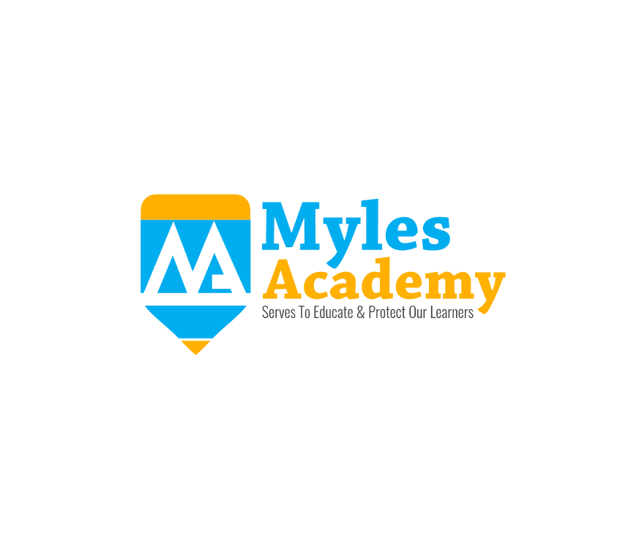

Myles Academy Expectations*

- Wear appropriate clothing.
- Always hand in your mobile phone and personal possessions when you enter the school.
- Do not use inappropriate language or conversation.
- Never fight, or use physically aggressive behaviour of any kind.
- Care for and look after the school site, the people in it and all equipment.
- Do not drop litter or damage equipment or property.
- Treat everyone with politeness, courtesy and respect. Do not use language which is abusive, offensive or rude.
- Listen to staff instructions. This is for everyone’s safety and wellbeing.
- Complete your class work on time and to the best of your ability.
- Bullying in any form is not tolerated.
- Don’t behave in a way that may be considered as putting any other child or adult at risk or in an unsafe situation.
- If you are struggling for any reason, let a member of staff know and use the quiet areas.
- Don’t disrupt other pupils learning.
- Have fun!

*This is not a conclusive list of all rules and expectations.
Appendix 2

Individual Child’s Education Risk Assessment
How to use this form
- Identify potential hazards e.g. self-harm, running away, vulnerability, communication, processing information, medical etc.
- Identify those affected by the hazard e.g. Child (YP), Staff (S), Other Children (OC) or Other Adults (OA)
- Determine the Severity of Outcome: ① Inconvenience/Problematic ② Distress ③ Minor Injury/Damage ④ Major Injury/Damage ⑤ Incapacity or Death/Total (Property) Loss
- Determine the Likelihood of Outcome: ① Very Unlikely to happen ② Unlikely ③ Possible ④ Probable ⑤ Certain to happen
- Calculate risk (Severity x Likelihood) and identify whether it is Low (1-6), Low Medium (8-12), High Medium (15-16), High (20), Very High (25)
- Identify what measures have been taken to reduce the severity or likelihood of harm e.g. staff support, therapy etc.
Where new and/or additional information is brought to the attention of a member of staff, please inform a member of SLT.
ALL RISK ASSESSMENTS SHOULD BE DEVISED, REVIEWED AND READ ALONGSIDE BMP

RISK ASSESSMENT FOR: | Date of Birth: |  | Admission Date:
 | Completed by: |  | Position:
 | Devised: |  | Reviewed:*

Hazards Identified | Person(s) Affected | Severity  (1-5) |  | Likelihood  (1-5) | Risk Calculation  Severity x Likelihood |  | Risk Level |  | Measures to Control Risk
Uncooperative & Disruptive Behaviour | YP S OC OA |  |  |  |  |  | L LM HM H VH
Additional Information
Physical Aggression towards peers/staff | YP S OC OA |  |  |  |  |  | L LM HM H VH
Additional Information
Out of bounds / Unauthorised absence / Missing from home, care or education | YP S OC OA |  |  |  |  |  | L LM HM H VH
Additional Information/Observations:
Substance Misuse | YP S OC OA |  |  |  |  |  | L LM HM H VH
Additional Information/Observations:

Verbal abuse/ Aggression | YP S OC OA |  |  |  |  |  | L LM HM H VH
Additional Information/Observations:

Self-injurious behaviour | YP S OC OA |  |  |  |  | L LM HM H VH
Additional Information/Observations:

Child sexual exploitation | YP S OC OA |  |  |  |  | L LM HM H VH
Additional Information/Observations:

Covid - 19 | YP S OC OA |  |  |  |  | L LM HM H VH
Additional Information/Observations:

Individual Child’s Behaviour Management Plan

Where new and/or additional information is brought to the attention of a member of staff, including preferred de-escalation techniques or the development risk-taking behaviours, staff must inform a member of the Leadership Team.
ALL PLANS SHOULD BE READ / UPDATED ALONGSIDE INDIVIDUAL RISK ASSESSMENTS.

Name of Child: |  |  | Review Date:
Date of Birth: |  | Admission Date:
Initial Plan Devised: |  | Plan Last Revised/Updated:
Likelihood of RPI: |  | Frequency of Review:
Education Review:

Positives including positive relationships, behaviours, interests and achievements

Triggers a description of situations that a child may find difficult to manage without support

Behaviors a description of behaviours that may occur during instances of increased support.

Further Information including other effective de-escalation techniques

Further Information including hazards and/or techniques which may be inappropriate or ineffective

Health Issues
including details/guidance on conditions which may impact on the child’s well-being during RPI

School SLT Signature: | Date
Key Worker / Staff Signature | Date

Appendix 3

Incident Report Log No:
EVERY PART MUST BE COMPLETED BY STAFF COMPILING THIS FORM
Name of pupil: |  | School:
Specific Location of Incident and PI:
Date of Incident: |  | Start time of Incident (24hr):
Name of staff completing this form: |  | Start Time of PI (24hr)
 |  | End Time of PI (24hr)
 |  | End time of incident (24):
Staff present / involved: |  | Other Young People present / Involved (Initials only)

Category of Incident (please highlight in Red for Negative Behaviour and Green for Neutral Behaviour)
Abuse against an adult | Abuse against a child | Allegation | Bullying | CSE | Damage
Dangerous behaviour | Disclosure | Drug and alcohol related | Missing | Persistent disruptive behaviour | Physical assault against an adult
Physical assault against a child | Racist abuse | Radicalisation | Self-harm / Self injury | Sexual misconduct | Theft
Other (specify):
Did the Incident result in a Physical Intervention? |  | Yes / No
If Yes, complete incident & PI

De-Escalation Strategies used: (please highlight)
Playfulness (humour) | Acceptance | Curiosity | Empathy
Planned ignore | Compromise | Positive regard | Distraction
Swap staff | Clear Direction | Other (Describe):
3Warnings | Change of Area

Incident/ Physical Intervention Details: (please give a factual account of what happened, describe the behaviour and explain why the actions taken by staff were in the best interests of the Young Person. Avoiding using words such as ‘kicked off or just aggressive, describe it in detail’

Outcomes/Consequences: (How was the incident brought to an end? What help and support was given to support the young person?)
Time of Physical Intervention (24hr)
Duration of hold(s)
Staff involved
Staff witness to intervention
Young People witness to intervention
Others witness to intervention
Reason for Restraint (Highlight all that are applicable) | Actual / Potential serious harm to self | Actual / Potential serious harm to others | Actual / Potential serious damage to property
Classification of Intervention(s) employed:
Non-Restrictive Physical Intervention used (Highlight those applicable)
Nurture Hold | Single Person Redirection | Other
If other is highlighted, describe:

Restrictive Physical Intervention techniques used (Highlight those applicable)
Static Close-In Hold Standing Restraint | Standing / Walking Restraint | Single Person Standing / Walking (young children) | Reverse Standing / Walking Restraint

Please state the full sequence of physical intervention techniques used

Were Emergency Services called? |  |  |  | Yes / No / NA
Details of service and log number
Date |  |  | Time |  | -
Who was informed? | Date | Time | Name of person informed | Informed by
Manager / Head Teacher
SLT (Reporting Upwards)
Placing Authority
Family
LADO
Ofsted (Regulation 40)
Social Worker
Other

Young Person’s Debrief (Staff to complete with the young person following all incidents, if student refuses please state why)

Debrief of Young Person completed by
Name |  | Date |  | Signed

Staff Debrief (Record details of any debrief completed with the team following a serious incident)
Staff Involved in debrief
Date of debrief |  | Time of debrief

Health Check List | Y or N | Date | Time | Details
Medical treatment must be offered to the young person – has this been done?
Is an Accident Report required?
Is a Body Map required?
Any Visual Injuries to Student or staff, if so give details

Incident / Physical Intervention Report completed by
Name |  | Date |  | Signed

